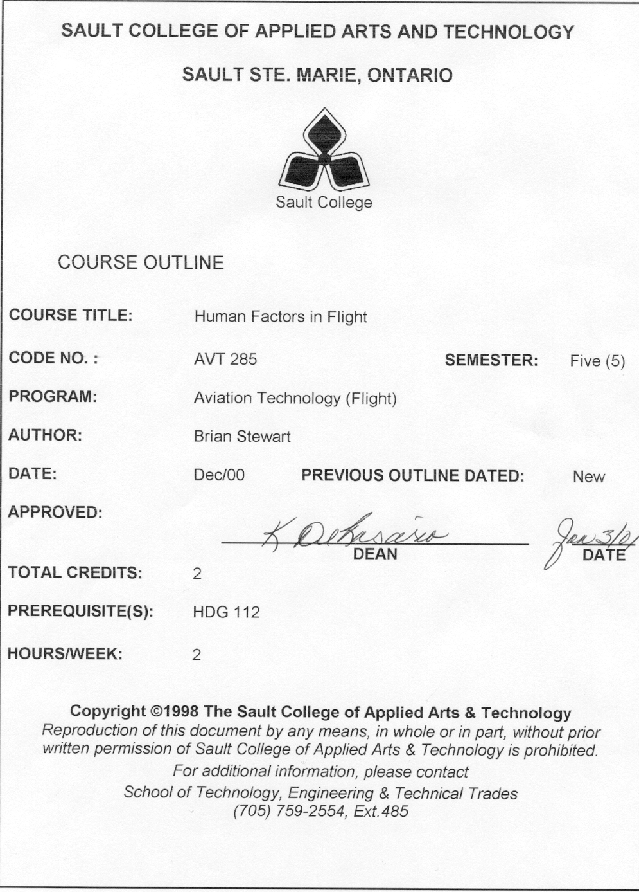

I. COURSE DESCRIPTION:
This is the second course involving human factors which aviation students are required to take. Personal Growth and Development discussed both physiological and psychological factors. The psychological factors where not directly linked to aviation, however many links could have been made. The physiological factors were all directly related to flight.
This semester you will learn how the psychological and physiological factors play an important role in flight safety. After the introduction your study will begin with pilot decision making for the general aviation pilot, followed by a description of human factors, the nature and sources of human error, sleep and the role it plays in the body’s functions, fitness and how it affects your performance, a review of vision and its associated illusions, motivation, communications, attitudes in aviation, training and training devices, displays and controls, cockpit layout and finishing with the cabin and it’s payload.

II. LEARNING OUTCOMES AND ELEMENTS OF THE PERFORMANCE:
Upon successful completion of this course the student will demonstrate the ability to:

- Describe the development of human factors in aviation.
Potential Elements of the Performance:
- role of human factors in aircraft accidents in recent years
- historical perspective on the development of human factors
- meaning of human factors

- Describe the man-environment interfaces of the SHEL conceptual model.
Potential Elements of the Performance:
- the meaning of each letter of the SHEL conceptual model
- characteristics of liveware
- the associated scientific disciplines of the characteristics of liveware
- interfaces of the SHEL model

- Describe and employ all aspects of the pilot decision making process.
Potential Elements of the Performance:
- what does pilot decision mean
- a simple model of a pilot’s performance
- attitudes and hazardous attitudes
- the process - situational awareness, evaluating options and deciding
- good judgment and factors affecting your good judgment
- behavior
- risk management
- communications
- Describe the nature of error.
Potential Elements of the Performance:
- normal distribution of human errors
- accident proneness
- Identify the sources of error.
Potential Elements of the Performance:
- mismatches between the SHEL components
- liveware errors during information processing
- role of motivation in performance
- role of arousal and alertness in performance
- factors affecting the decision making process
- eye witness errors
- Identify errors, classify errors and propose mitigations to reduce errors.
Potential Elements of the Performance:
- four ways to classify errors
- differences between humans and machines performing tasks
- error reduction
- Describe the role of fatigue, body rhythms, and sleep in flight performance.
Potential Elements of the Performance:
- effect of jet lag and fatigue on performance
- role of body rhythms on performance
- types of sleep
- role of sleep and effects on performance
- insomnia and sleep drugs
- Be knowledgeable about the occurrence of incapacitation and explain the relationship between physical fitness, mental fitness and performance.
Potential Elements of the Performance:
- total and partial incapacitation
- benefits of physical fitness
- effects of smoking, drugs and alcohol on physical fitness and ultimately flight safety
- stress
- importance of diet
- Explain how the eye functions and it's role in perception
Potential Elements of the Performance:
- measurement of light
- terms and functions of the eye
- visual perception
- blind spots
- depth and distance perception
- effects of hypoxia and smoking
- Know when and why visual illusions occur
Potential Elements of the Performance:
- optical illusions
- depth and distance illusions
- sensory illusions
- categorize illusions according to phase of flight
- minimizing your susceptibility to illusions
- meaning of design eye reference
- Describe the role of motivation in our ability to perform
Potential Elements of the Performance:
- human behavior in accident investigation
- definition of motivation
- theories of motivation
- influencing motivation
- Explain the meaning, qualities and role of leadership
Potential Elements of the Performance:
- role of a leader
- characteristics and tasks of a leader
- Describe communication in terms of how information is exchanged, types, intelligibility, characteristics and barriers
Potential Elements of the Performance:
- define communication
- types of communication
- elements of communication
- factors which make words more understandable (intelligible)
- the influence that expectation can have on the meaning of the message
- parts of the vocal and auditory system
- factors affecting hearing
- Differentiate between personality, attitudes, beliefs and opinions; explain the influences on attitudes, changing attitudes and why safety doesn’t sell.
Potential Elements of the Performance:
- personality, attitudes, beliefs and opinions in aviation
- nature, function and measurement of attitudes
- group influences on attitudes
- changing attitudes
- selling safety
- Explain how we learn, the process that is involved and examples of training aids and devices.
Potential Elements of the Performance:
- define education, training and skills
- the cycle of training
- the learning process
- training aids and training equipment
- Describe the links between the learning process and documentation (manuals, checklists, charts).
Potential Elements of the Performance:
- meaning of documentation
- language , layout and text of effective documentation
- application of human factors on charts and maps
- Understand the use and limitations of displays and warnings
Potential Elements of the Performance:
- historical development of cockpit displays and controls
- the SHEL interface between liveware and hardware
- design aspects of displays; including classifications, markings, presentations, CRT’s and HUD
- fail-passive and fail operational concepts in automatic landing systems
- warning, alert and advisory systems
- Recognize the importance of and/or the deficiency in the type and location of controls
Potential Elements of the Performance:
- functions of controls
- design principles for cockpit controls
- keyboard layout and flight deck applications
- use of autopilots
- Appreciate and understand the challenges in flight deck design and space utilization
Potential Elements of the Performance:
- application of human factors in usage of space
- anthropometry and biomechanics
- fitting the human into the design and space available
- making the design functional and comfortable
- Develop both an awareness and an appreciation for the challenges in the passenger cabin
Potential Elements of the Performance:
- human factors applied in the cabin design
- emergencies
- cabin environment
- Interface between people
Potential Elements of the Performance:
- communications in the cabin and the cockpit
- dealing with passengers – intoxication and fears
- crash statistics
- hijacking
- Be knowledgeable about human factors and understand how to apply them in the aviation environment
Potential Elements of the Performance:
- qualifications for human factors specialist
- human factors training
- aim of crew resource management
- application of human factors in deign and its incorporation into company culture
III. TOPICS:
- Background to Human Factors
- The SHEL Conceptual Model
- Pilot Decision Making
- The Nature of Error
- Sources of Error
- Error Classification and Reduction
- Fatigue, Body Rhythms
- Fitness and Performance
- Vision
- Visual Illusions
- Motivation and Safety
- Communication
- Attitudes and Persuasion
- Training and Training Devices
- Documentation
- Displays
- Controls
- Space and Design
- Human Factors in the Cabin
- Interface Between People
- Further Education and Human Factors Applications
IV. REQUIRED RESOURCES/TEXTS/MATERIALS:
- Human Factors in Flight – Frank H Hawkins
- Human Factors in Flight – Workbook – Craig S Funk
V. OTHER RESOURCES/TEXTS/MATERIALS:
- From the Ground Up
- A.I.P. - aeronautical information publication
- Basic Flight Physiology – Richard O Reinhart (Second Edition)

McGraw -Hill ISBN # 0-07-052223-5
- Human Factors for General Aviation – Stanley Trollip & Richard Jensen

Jeppesen Sanderson ISBN # 0-88487-138-X
- Aviation Safety Programs
Jeppesen Sanderson ISBN # 0-88487-236-X
- Human Factors in Aviation

Earl L Wiener, David C Nagel
- Pilot Judgement and Crew Resource Management

Richard S Jensen
- Human Factors in Multi Crew Operations

Harry W Orlady
- Flight Safety – A Primer for General Aviation Pilots

Alexander T Wells
- Human Factors for Aviation - Basic Handbook - Transport Canada
- Pilot – Mental and Physical Performance

David C Edwards
- Beyond Aviation Safety Human Factors

Daniel E Maurino, James Reason, Neil Johnston, Rob B Lee
- Flightdeck Performance

Stanley Roscoe
Internet Access
http://www.psy.utexas.edu/psy/helmreich/nasaut.htm
http://www.hf.faa.gov/
http://www.crm-devel.org/resources/human.htm
http://flightsafety.org/human_factors.html
http://www.tc.gc.ca/aviation/general/human/litrev/hfflt1e.htm

VI. EVALUATION PROCESS/GRADING SYSTEM
- The student will be assessed by tests.
- Term tests | 50%
- Final Exam | 50%

The following semester grades will be assigned to students in post secondary courses:

Grade | Definition | Grade Point Equivalent
A+ | 93-100% | 4.0
A | 87-92% | 3.75
B | 80-86% | 3.0
C | 70-79% | 2.0
R | Below 70% | 0.0

 | CR (Credit) | Credit for diploma requirements has been awarded.
 | S | Satisfactory achievement in field placement or non-graded subject areas.
 | U | Unsatisfactory achievement in field placement or non-graded subject areas.
 | X | A temporary grade. This is used in limited situations with extenuating circumstances giving a student additional time to complete the requirements for a course (see Policies & Procedures Manual – Deferred Grades and Make-up).
 | NR | Grade not reported to Registrar's office. This is used to facilitate transcript preparation when, for extenuating circumstances, it has not been possible for the faculty member to report grades.

- Students may request a deferment of a test for compassionate reasons. Compassionate Grounds for deferment will include but not be limited to death of an immediate family member, personal illness, or recent diagnosis of a serious illness of a family member. Rewrites will not be permitted after the fact for compassionate reasons.
- “R” grades in any subject at the end of a semester will result in termination from the program. Re-writes in aviation subjects are not permitted except as provided in the re-write policy below.
- Attendance is mandatory for all Aviation classes unless approval is granted in advance.
- Although attitude, co-operation, etc., are not graded, students may be terminated based on their performance in this area. These attributes are also considered in the selection of the Air Canada Award and other scholarships.
- Dates of tests will be announced at least 1 week in advance.

RE-WRITE POLICY
- No re-writes on term tests.
- In the event of a failure the final exam of AVT 285 may be re-written provided the semester average is 70% or greater and the failed final exam is within 5% of a pass. (i.e. 65% or above). The re-written final exam will be averaged with the failed final exam to determine the resulting mark which must be 70% or above to pass.

VII. | SPECIAL NOTES:
Special Needs:
If you are a student with special needs (e.g. physical limitations, visual impairments, hearing impairments, or learning disabilities), you are encouraged to discuss required accommodations with your instructor and/or the Special Needs office. Visit Room E1204 or call Extension 493, 717, or 491 so that support services can be arranged for you.

Retention of course outlines:
It is the responsibility of the student to retain all course outlines for possible future use in acquiring advanced standing at other post secondary institutions.

Plagiarism:
Students should refer to the definition of “academic dishonesty” in Student Rights and Responsibilities. Students who engage in “academic dishonesty” will receive an automatic failure for that submission and/or such other penalty, up to and including expulsion from the course/program, as may be decided by the professor/dean. In order to protect students from inadvertent plagiarism, to protect the copyright of the material referenced, and to credit the author of the material, it is the policy of the department to employ a documentation format for referencing source material.

Course outline amendments:
The Professor reserves the right to change the information contained in this course outline depending on the needs of the learner and the availability of resources.

VIII. | PRIOR LEARNING ASSESSMENT:
 | Students who wish to apply for advanced credit in the course should consult the professor. Credit for prior learning will be given upon successful completion of a challenge exam or portfolio.
IX. | DIRECT CREDIT TRANSFERS:  Students who wish to apply for direct credit transfer (advanced standing) should obtain a direct credit transfer form from the Dean’s secretary. Students will be required to provide a transcript and course outline related to the course in question.

